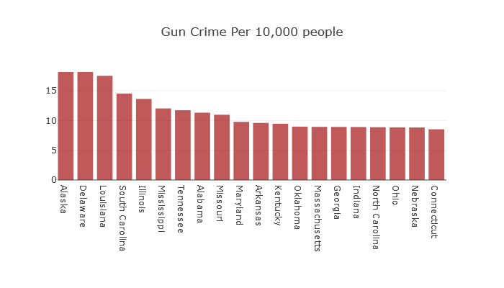

A lot of articles I’ve seen lately on gun violence tend to focus on big cities, and why shouldn’t they? Big cities are where large portions of the population live. This means that if you want your article to feel relevant it’s a sensible decision to focus on those. And if you want people to feel unsafe, there's always some guns to remind them that they live in dangerous times. Right?

A group called the [Gun Violence Archive](https://www.gunviolencearchive.org/) keeps up to date information on gun violence since 2013. Note that they do not fully report [suicide.](https://www.cdc.gov/nchs/data/nvsr/nvsr67/nvsr67_05.pdf) Suicide accounts for roughly 2/3 of all gun violence incidents. They do, however, allow us to draw in their data for easy access. And this allows us to cross reference it with other sources, such as the [USA mortality map](https://www.infino.me/mortality/usmap). And what do we find?

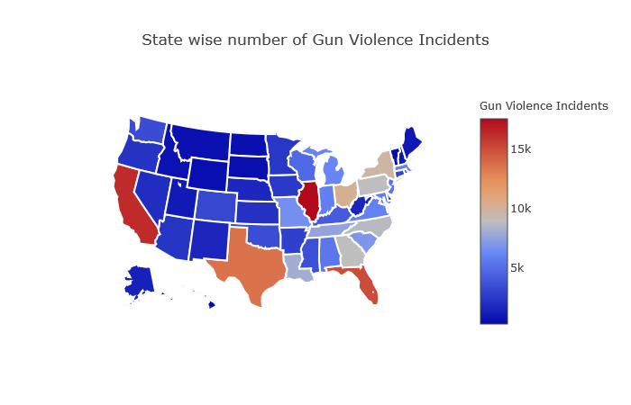

Well, for starters, the big cities contain big blobs of gun violence, as you might expect. Yet, the astute among us may point out something here. Bigger cities have more people, so shouldn’t the numbers be higher by default?

The answer is yes! and good job, A+! Luckily, it’s a trivial matter to then convert the raw crimes data. I did a breakdown per state and per arbitrary number of people(i chose 10,000 because it seems informative). Doing this gives us something like the top chart.

If you notice now, the relationships seem almost flipped on their head! No more California, no more New York, no more Texas, no more Florida even in the top! What do show up are a lot of states with:

- high suicide rates(Alaska),

- lots of poor people(Missouri), and

- Illinois, which manages to be high on gun violence both per capita and in raw numbers(I didn’t want to visit anyway).

So what’s the takeaway? Well, perhaps we have two things. Raw numbers wise, ⅔ of all gun deaths in the USA are suicides. This means the gun violence numbers reported are rather innaccurate. Also, The top state on our top 20 chart for instance is Alaska, which is mostly suicide deaths. Even so, it has only 18 gun violence incidents per 10,000 people!

So, don’t get caught up too much in the fear cycle. And remember, everyone who wants a reaction out of you usually wants to sell you something.

Oh, and don’t visit Illinois. Guess that’s three things.